# Generating Zoom meeting using Node JS

Today, I'm going to show you how to use nodejs to build a Zoom conference. We need to send meeting URLs without passwords in some meeting schedule projects so that members can join the meeting with just a link. So, let's get started.

## What is Zoom:

Zoom is a cloud-based video conferencing service that allows you to virtually connect with others while conducting live discussions, and it also allows you to record those sessions to watch later. Zoom was reportedly utilized by more than half of Fortune 500 organizations in 2019, and it is expected to expand even more in 2020, with a 227 percent increase year over year.

## Zoom API:

Developers can use the Zoom API to get information from Zoom. On the Zoom App Marketplace, you may use this API to create private services or public apps. In this article, we are going to discuss how we can use zoom api for generating zoom meeting link.

## Initial Setup:

1. Create an empty directory with any name you want.
2. Open the folder with any code editor. I would like to prefer VS Code.
   1. You can download vs code from here. <https://code.visualstudio.com/>
3. Now press ctrl + shift + ~ to open terminal.
4. Now type ***npm init -y*** and hit enter. It will create package.json file and install necessary node modules
5. Now type ***npm install express nodemon cors dotenv request-promise jsonwebtoken***
6. Now create an empty file namely server.js and put below code in it.

const express = require("express");

const cors = require("cors");

const dotEnv = require("dotenv");

const app = express();

//registering middlewares

dotEnv.config();

app.use(cors());

app.use(express.json());

//listening to port

const port = process.env.PORT || 5000;

app.listen(port, () => {

  console.log(`Server is running on ${port}`);

});

### Registering application

You'll need the zoom app's jwt API key and token now. You can create these app details by going to the developer section of the Zoom website. Please take the following steps:

1. Go to your developer account on Zoom. <https://developers.zoom.us/>
2. After that, click the BUILD APP button to create your Zoom account, and you'll get this screen after logging in.

1. Now click on JWT
2. Now you need to add you details and you will have following details

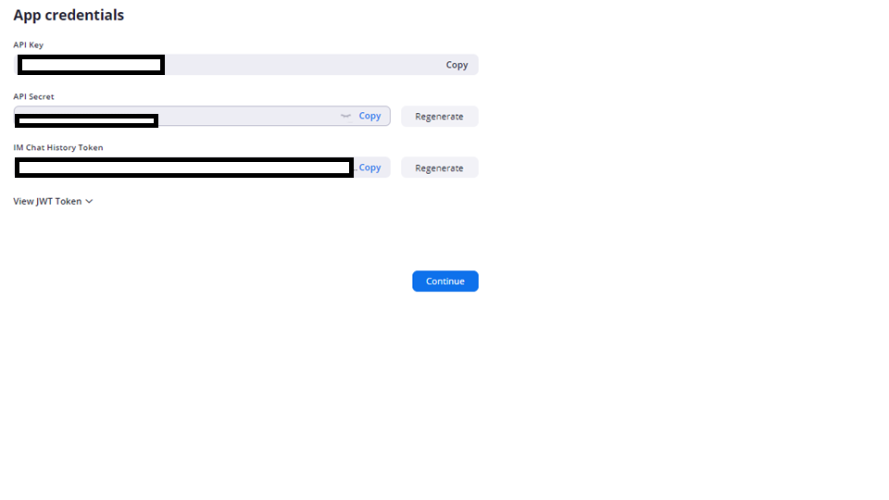

1. Now create an empty file named as “.env” in src directory
   1. Create variable API_KEY = your API KEY
   2. Create variable API_SECRET = your API SECRET

1. Now create routes folder inside root directory
2. And create an empty file namely zoomRouter.js
3. Now put following code inside it

const express = require("express");

const router = express.Router();

const requestPromise = require("request-promise");

const jwt = require("jsonwebtoken");

require("dotenv").config();

const payload = {

  iss: process.env.API_KEY, //your API KEY

  exp: new Date().getTime() + 5000,

};

const token = jwt.sign(payload, process.env.API_SECRET); //your API SECRET HERE

router.get("/createMeeting", (req, res) => {

  email = "developerEmail@gmail.com"; // your zoom developer email account

  var options = {

    method: "POST",

    uri: "https://api.zoom.us/v2/users/" + email + "/meetings",

    body: {

      topic: "Zoom Meeting Using Node JS", //meeting title

      type: 1,

      settings: {

        host_video: "true",

        participant_video: "true",

      },

    },

    auth: {

      bearer: token,

    },

    headers: {

      "User-Agent": "Zoom-api-Jwt-Request",

      "content-type": "application/json",

    },

    json: true, //Parse the JSON string in the response

  };

  requestPromise(options)

    .then(function (response) {

      console.log("response is: ", response);

      res.send("create meeting result: " + JSON.stringify(response));

    })

    .catch(function (err) {

      // API call failed...

      console.log("API call failed, reason ", err);

    });

});

module.exports = router;

Putting all together:

Server.js:

const express = require("express");

const cors = require("cors");

const dotEnv = require("dotenv");

const zoomRouter = require("./router/zoomRouter");

const app = express();

//registering middlewares

dotEnv.config();

app.use(cors());

app.use(express.json());

//registering routes

app.use("/zoomapi", zoomRouter);

//listening to port

const port = process.env.PORT || 5000;

app.listen(port, () => {

  console.log(`Server is running on ${port}`);

});

Now we will test it out in browser. First, lets add “start” script in package.json,

then we will start server by command ***npm start***

In this image we can see, there is key “start_url”, we need to copy the url and paste it in browser. It will open zoom meeting for us. 😊

I hope you really enjoyed this amazing tutorial for creating zoom meetings with node js. You can also read more about zoom api at <https://marketplace.zoom.us/docs/guides/>